First approach: using definitions provided by Manne

* **Feminine-coded goods and services:** The characteristics that women are expected to naturally provide to men because they are entitled to receive the benefits of women’s goods and services. Moreover, these characteristics are used to reinforce traditional gender roles.
* **Gendered split perception:** Women are judged more harshly than their male counterparts on the basis of what we take to be the same actions, on the assumption that these perceptions are more or less morally neutral common ground here. But evidence suggests that the same actions performed by a man versus a woman may be viewed differently in the first place - where a lens of differential prior suspicion or a gendered division of labor makes the very same actions performed by her versus him seem different. His behavior seems normal, unremarkable, business as usual, nothing to see here. Her doing the same thing makes us wonder: what’s she hiding?
* **Testimonial injustice:** Arises due to systematic biases in the economy of credibility. It afflicts members of a certain social group, most notably when the group has historically been and to some extent remains unjustly socially subordinate. Testimonial injustice then paradigmatically consists in subordinate group members tending to be regarded as less credible when they make claims about certain matters, or against certain people, hence being denied the epistemic status of knowers, in a way that is explained by their subordinate group membership.
* **Social dominance penalty:** People are (often unwittingly) motivated to maintain gender hierarchies, by applying social penalties to women who compete for, or otherwise threaten to advance to, high-status, masculine-coded positions. Social dominance penalty is where women in such positions who are agentic (i.e., competent, confident, assertive) are perceived as extreme in masculine-coded traits like being arrogant and aggressive.

**Problem:** high similarity scored posts and comments were mostly generic feedback and advice that followed a similar context to the definitions.

Second approach: slightly modifying the definitions to include the context of women software developer experiences

* **Feminine-coded goods and services:** The experiences that women software developers encounter where they are expected to naturally provide to men because they are entitled to receive the benefits of women’s goods and services. Moreover, these characteristics are used to reinforce traditional gender roles.
* **Gendered split perception:** "Women software developers experience harsh judgment compared to their male counterparts on the basis of what we take to be the same actions, on the assumption that these perceptions are more or less morally neutral common ground here."
* **Testimonial injustice:** Arises due to experiences of systematic biases in the economy of credibility. It afflicts members of a certain social group, most notably when the group has historically been and to some extent remains unjustly socially subordinate, such as women software developers.
* **Social dominance penalty:** People are (often unwittingly) motivated to maintain gender hierarchies, by applying social penalties to women software developers who compete for, or otherwise threaten to advance to, high-status, masculine-coded positions. It is where women in such positions who are agentic (competent, confident, assertive) experience the perception of being extreme in masculine-coded traits like being arrogant and aggressive.

Problem: high similarity scored posts and comments contained similar contexts to the given definitions. However, the majority did not meet the criteria of women software developer experiences. For example, in feminine-coded goods and services:

"Holy smokes YTA. I am a woman developer and there is so much wrong with your post I just can't believe it's real. From the racist fetishisation, to excusing your team's actions of not treating her as an equal and putting the reasoning onto her rather than onto them. I honestly feel like many men developers subconsciously think they have a "right" to work in a nerdy male only environment where they don't have to worry about how they come across to women, as if it's perk of choosing that industry and how could they have known they would have to learn how to talk to women? Ridiculous and inexcusable."

Third approach: slightly modifying the definitions to include the context of women software developer experiences

* **Feminine-coded goods and services:** The experiences that women software developers encounter where they should naturally provide certain attributes such as care, empathy, and support, to men to reinforce traditional gender roles. Consequently, female software engineers may find themselves disproportionately burdened with expectations related to nurturing and emotional labor, alongside their technical responsibilities.
* **Gendered split perception:** Women software developers experience harsh judgment compared to their male counterparts, facing scrutiny for actions that may be perceived similarly but are subject to differential treatment. This bias assumes a morally neutral common ground, yet evidence suggests otherwise. The same actions performed by a man versus a female software engineer may be viewed through different lenses from the outset. Factors such as prior suspicion or gendered divisions of labor influence perceptions, leading to disparate interpretations of identical behaviors. While a man's actions may be deemed normal or unremarkable, a woman in tech's equivalent actions can prompt questions and suspicions, fostering an environment of scrutiny and doubt.
* **Testimonial injustice:** Emerges from systemic biases against women software developers ingrained within the economy of credibility. This phenomenon disproportionately affects women in tech belonging to marginalized social groups, notably those historically and persistently subjected to unjust social subordination, such as female software engineers. It manifests when female software devs being part of subordinate groups are systematically perceived as less credible when making claims about specific topics or against particular individuals. Consequently, women coders experience denial regarding the epistemic status of knowers, solely due to their membership in a subordinate group. This bias undermines female developers’ ability to be recognized and respected for their knowledge and expertise.
* **Social dominance penalty:** Coders may find themselves compelled, often unintentionally, to uphold gender-based hierarchies. This manifests through the imposition of social sanctions on women software developers and aspire to or demonstrate potential to ascend to esteemed, typically male-associated roles within the field. In this context, female software engineers who exhibit agency—characterized by traits such as competence, confidence, and assertiveness may experience a phenomenon wherein their behaviors are perceived as deviating excessively towards masculine-coded attributes. Consequently, women in tech might be exposed to labels such as overly arrogant or aggressive due to societal norms that prescribe certain behaviors as more appropriate or acceptable based on gender.

Problem: Feminine-coded goods and services contains over half of the dataset which is highly unlikely. The highest scored posts and comments from the other categories are somewhat match the given definition. However, they do not explicitly focus on women software developer experiences.

Fourth Approach: Use a verbose definition of women software developer experiences using as many synonyms as possible then categorize based on threshold.

Women: female, lady, girl,

Software developers: software engineer, programmer, coder, developer, in tech, computer scientist

Experiences: encounter, incident, occurrence, event, happening

“Women software developers, within the realm of software development, encounter a spectrum of challenges, including gender biases and societal expectations. Despite female software engineers' technical expertise, women in tech often experience skepticism and marginalization in male-dominated environments. However, women programmers' resilience and advocacy contribute to broader efforts aimed at fostering inclusivity and diversity within the industry."

Problem: started seeing male experiences and assumptions related to gender biases, inclusivity, diversity, etc.

“As a women software developer, I experience various challenges while working in male-dominated programming teams and in the tech industry. Despite female software engineers and computer scientists having technical expertise and years of knowledge, lady coders face gender biases.”

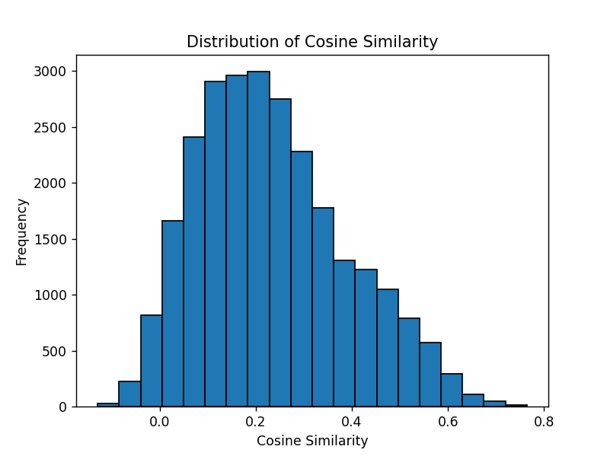

“As a woman software engineer, I experience various challenges while working in male-dominated software development teams and throughout my career in the tech industry. Despite female devs having technical expertise and years of knowledge, lady programmers are often faced with gender biases and sexism.”

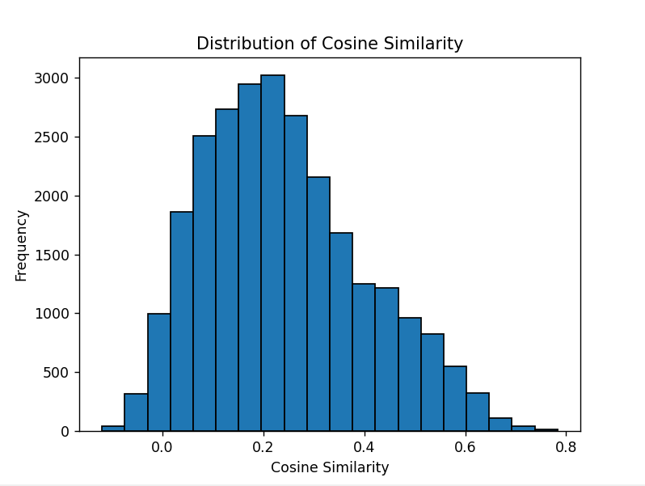

Problem: Gives women software developer experiences (yay) but we want to target sexism experience. Many top posts and comments state how there isn’t much sexism in the industry.

“As a female software engineer, I am confronted with significant challenges stemming from gender biases and sexism within male-dominated tech environments. These biases hinder women software developers’ ability to assert our expertise and advance in our careers on equal footing with male peers. Overcoming these obstacles requires concerted efforts to address systemic issues of inequality and promote a more inclusive and supportive environment for women in the tech industry.”

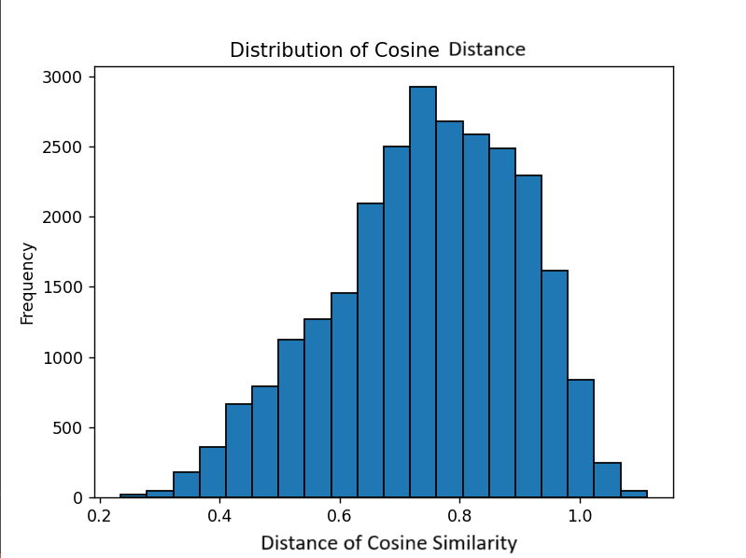

"I am a woman software engineer. I experience sexism and prejudice while working in software development teams. Female programmers encounter challenges such as expectations to follow traditional gender roles, colleagues harshly judging women devs' actions, encountering systemic biases throughout their careers, and facing social penalties for being a woman in tech."

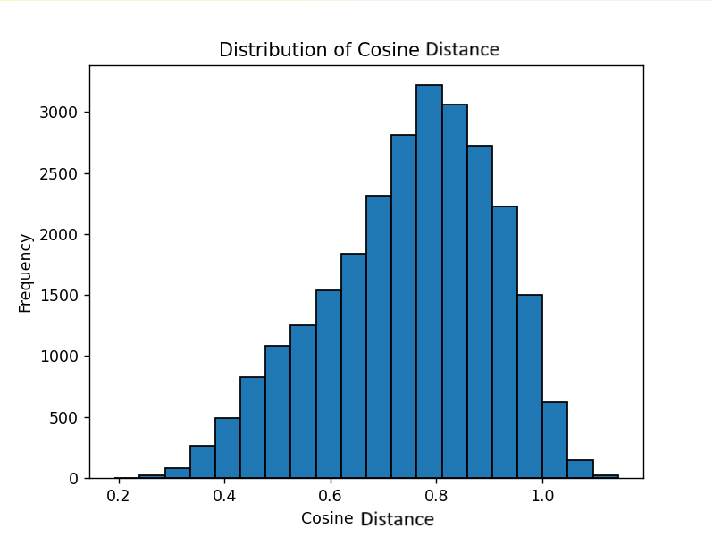

Precision = 1/10

"I am a woman software engineer and and I sometimes feel prejudice while working in software development teams. Female programmers encounter challenges such as expectations to follow traditional gender roles, colleagues harshly judging women devs' actions, feeling ignored or perceived as less creditable, encountering systemic biases, and facing social penalties for being a woman in tech."

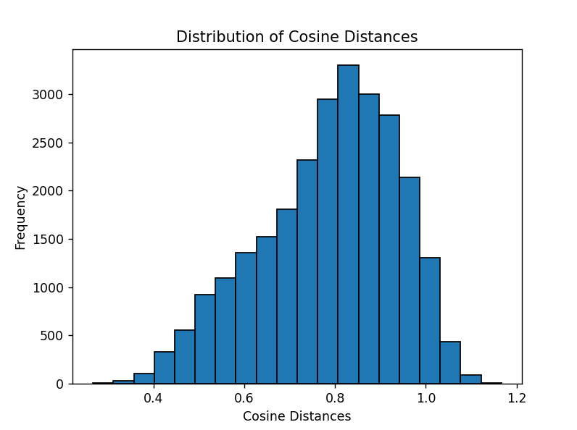

Precision = 1/10

“The experiences that women software engineers encounter when collaborating in software development teams where they feel self doubt and isolated by their male colleagues. Consequently, female software developers may find themselves disproportionately burdened with additional expectations due to their gender alongside their technical responsibilities.”

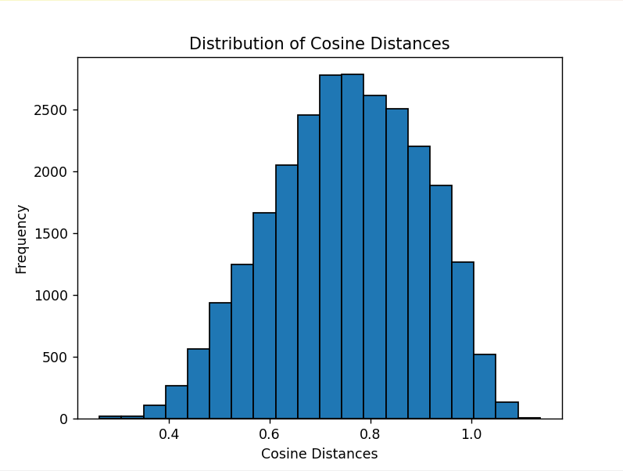

Precision = 3/10

The experiences that women software developers encounter in software development teams where they should provide certain attributes to their male colleagues to be perceived as equally knowledgeable programmers. Consequently, female software engineers may find themselves disproportionately burdened with expectations alongside their technical responsibilities to progress in their career.

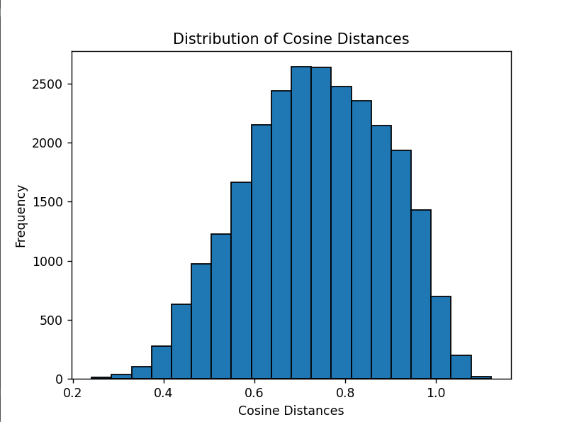

Precision = 2/10

The negative experiences that women software developers encounter while working with male colleagues in their technical teams. Many female software engineers face challenges such as gender bias, discrimination, sexism, or misogyny while progressing through their careers.

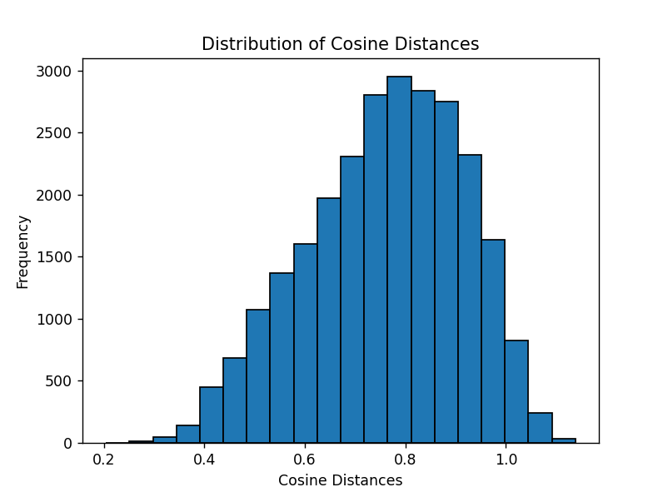

Precision = 4/10

The negative personal experiences that women software developers encounter while working with colleagues in their technical teams. Female software engineers frequently confront detrimental interactions when collaborating with peers in their software development teams.

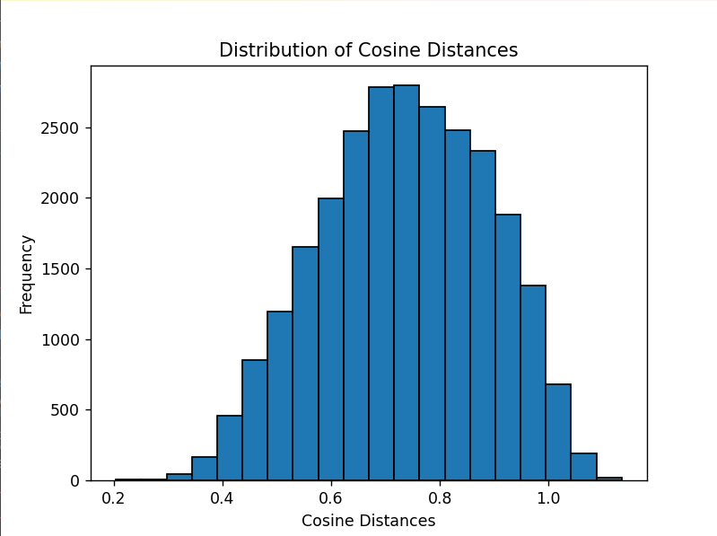

Precision = 3/10

The negative personal experiences that women software developers encounter while working with colleagues in their technical teams. Female software engineers are sometimes confronted with horrible interactions when collaborating with their programming peers. The tech industry is dealing with a gender gap as women do not feel welcome or ignored while participating in their coding groups.

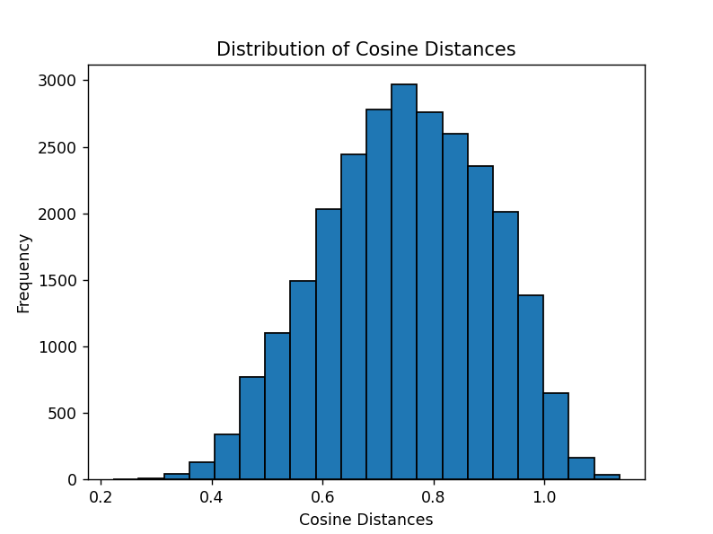

Precision = 3/10

The negative experiences that women software developers encounter while working with male colleagues in their technical teams. Female software engineers face challenges and feel different compared to the other programmers, which hinders career advancement and internal doubt.

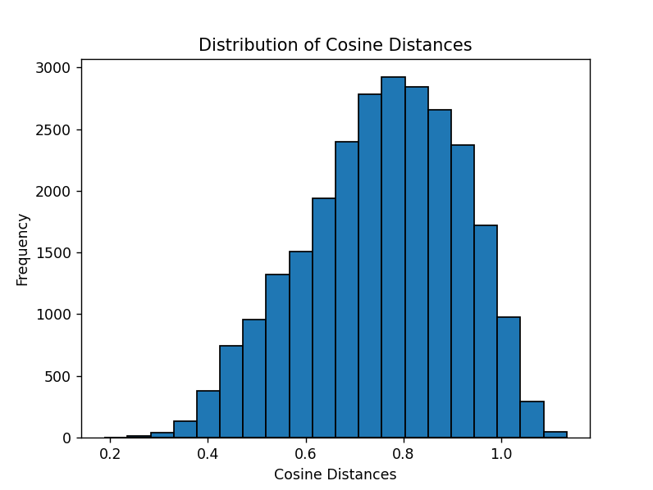

Precision = 2/10

“The challenges faced by women in technical fields due to societal biases and unequal treatment. Female professionals in software development often encounter obstacles such as gender-based discrimination, unequal opportunities, and social dynamics that may inhibit their career advancement. These challenges can manifest in various forms, including biases in hiring and promotion, unequal recognition of achievements, and subtle forms of exclusion or marginalization within professional environments.”

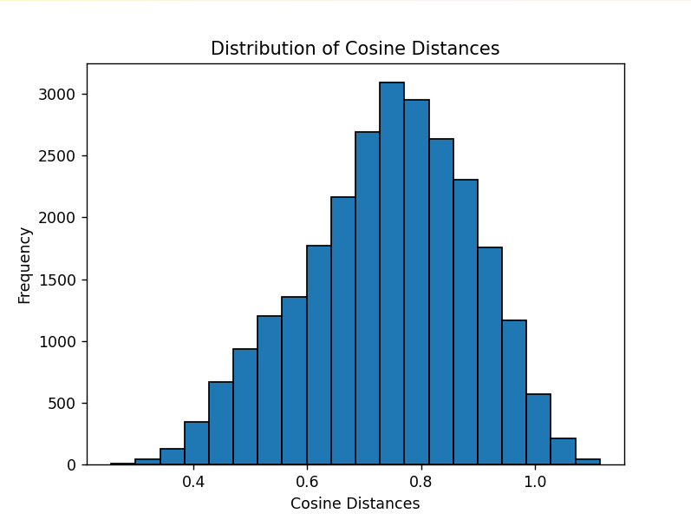

Precision = 4/10 but around the end of the boundary

= 15/50 = 3/10

“The negative experiences that women software developers encounter while working with male colleagues in their technical teams. Female software engineers often face obstacles such as gender-based discrimination, unequal opportunities, and societal biases that may inhibit their career advancement. These challenges can manifest in various forms, including lack of hiring and promotions, uneven recognition of achievements, and subtle forms of exclusion within their software development group.”

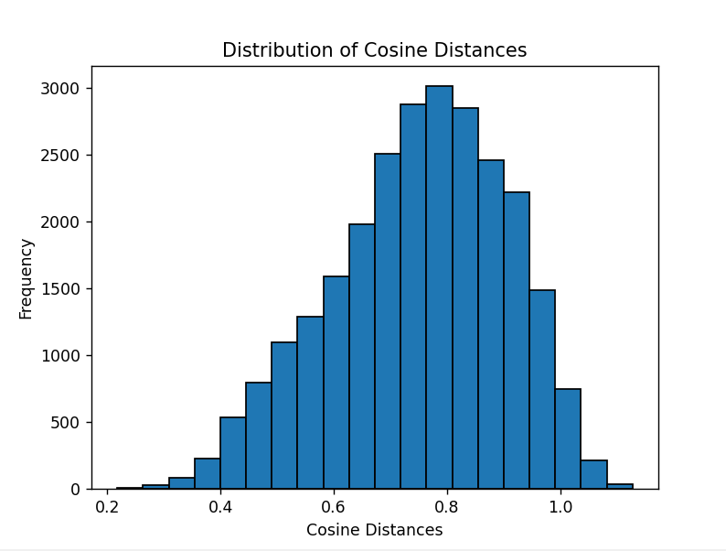

Precision = 2/10

“The professional hurdles encountered by women in software engineering due to systemic biases and unequal treatment. Female software developers experience obstacles such as gender-based discrimination, limited representation in educational and professional settings, and challenges in navigating workplace dynamics. These difficulties can arise from ingrained societal norms and cultural biases, leading to disparities in opportunities and recognition within the industry.”

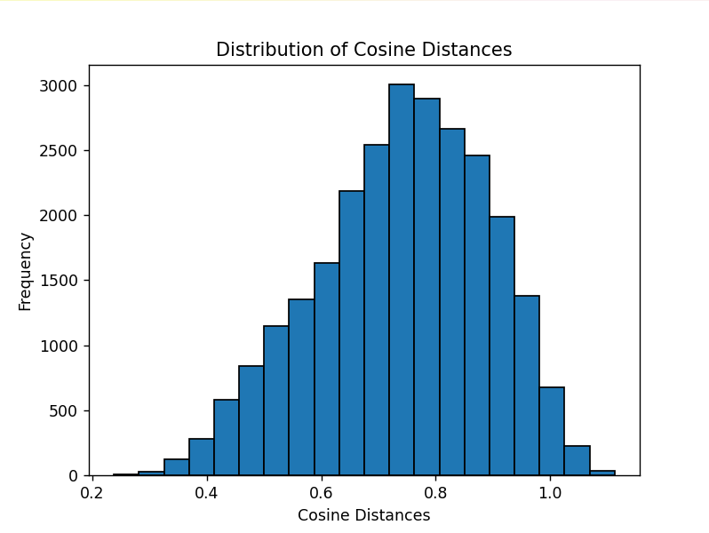

Precision = 1/10

“The disadvantageous experiences that women software engineers encounter where they are assumed to naturally provide certain attributes to their male colleagues. Unfortunately, women programmers may find themselves disproportionately burdened with additional expectations to their software development teams which negatively impacts their overall performance and perspective of the industry.”

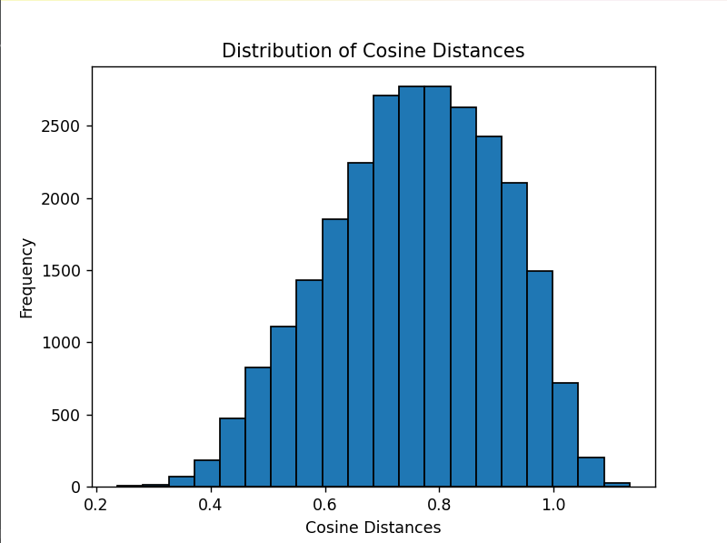

Precision = 3/10

The negative experiences that women software engineers encounter while working with colleagues in their technical teams such as sexism and gender bias.

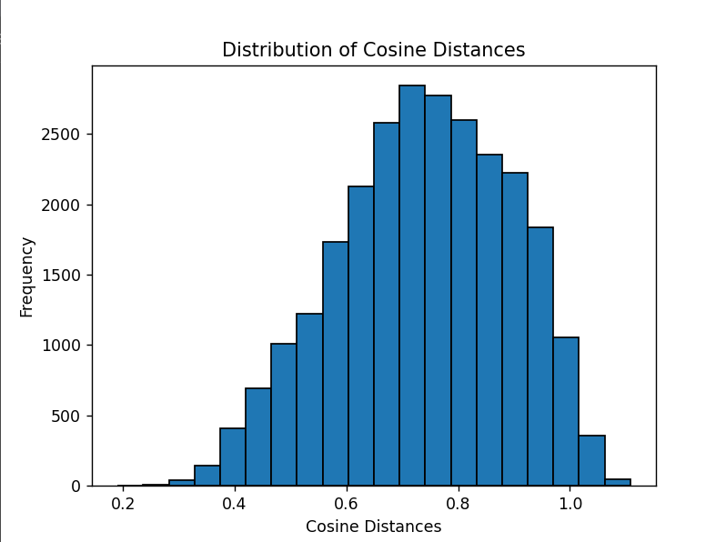

Precision = 4/10

The negative experiences that women software engineers encounter while working with colleagues in their teams such as sexism and hostile environment.

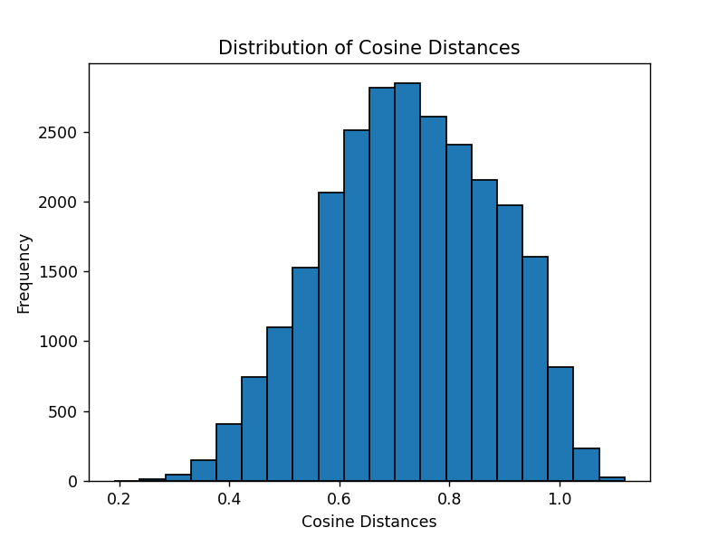

Precision = 5/10

= 18/50

= /100

As a female software engineer, woman in tech, and women software developer, I’ve faced challenging situations while collaborating with colleagues in my teams. These include encountering sexism and navigating a hostile environment.

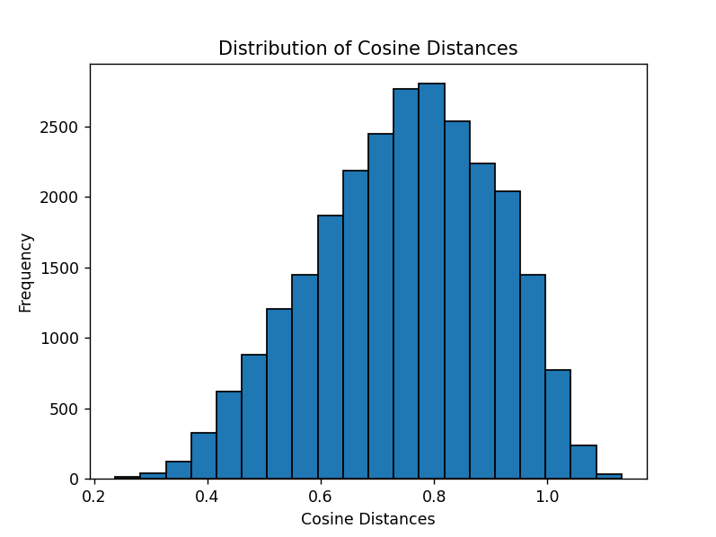

Precision = 5/10

Precision = 17/50 = 0.34

Precision = 30/100

As a female software engineer, woman in tech, and women software developer, I’ve faced challenging situations and experienced issues while collaborating with colleagues in my teams. These include encountering sexism and navigating a hostile work environment.

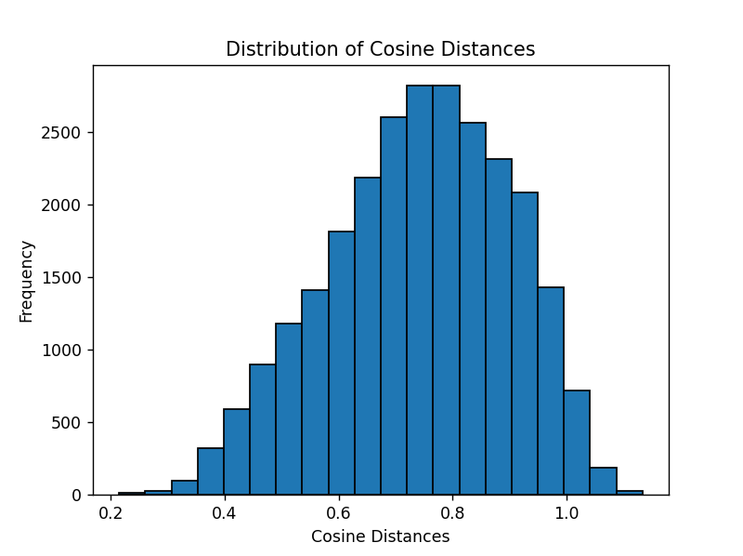

Precision = 4/10

As a female software engineer, woman in tech, and women software developer, I’ve faced challenging situations and experienced issues while collaborating with colleagues in my teams. These include encountering sexism, navigating a hostile work environment, and receiving unequal treatment.

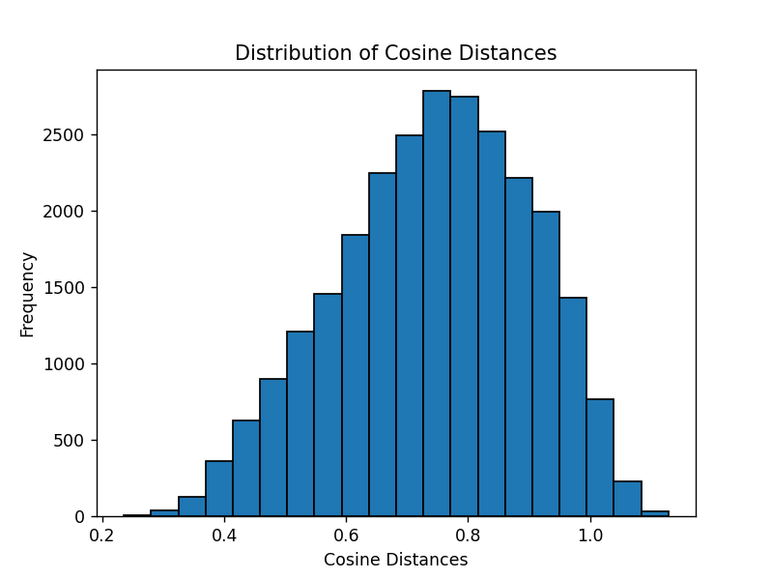

Precision = 5/10

Precision = 16/50 = 0.32

As a woman software engineer, I’ve faced challenging situations and experienced issues while collaborating with colleagues in my teams. These include encountering sexism, navigating a hostile work environment, and receiving unequal treatment.

